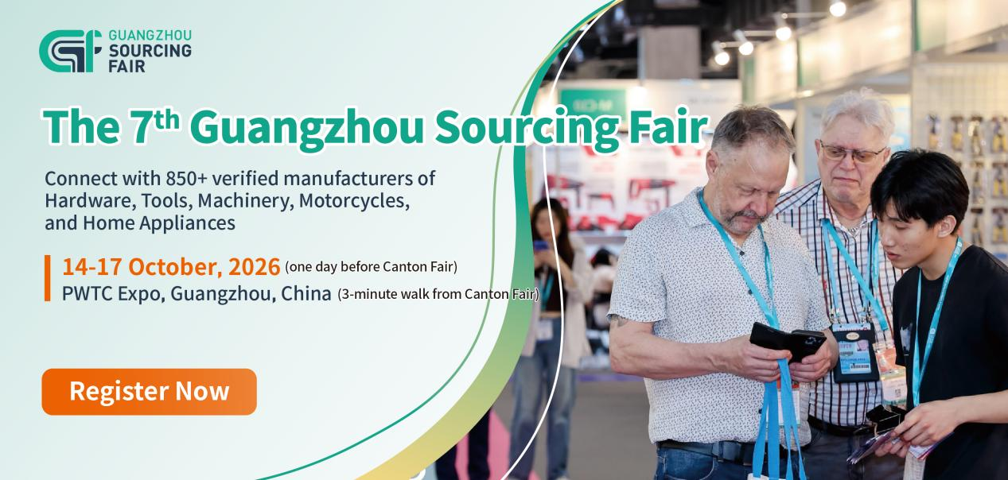
The 7th Guangzhou Sourcing Fair (GSF)
One Trip, Double the Reach – Maximize Your Sourcing Efficiency in China

The 7th Guangzhou Sourcing Fair (GSF), co-organized by Global Sources, Poly Exhibition, and Grandhub, will take place from October 14 to 17, 2026, at Poly World Trade Center Expo, strategically timed alongside the Canton Fair for a comprehensive, efficient sourcing experience.
This edition will connect you with over 850 reputable Chinese manufacturers specializing in four key sectors: Hardware & Tools, Machinery & Equipment, Motorcycles & Accessories, and Home Appliances. It's your opportunity to discover innovative products and build valuable supplier relationships—all in one trip.
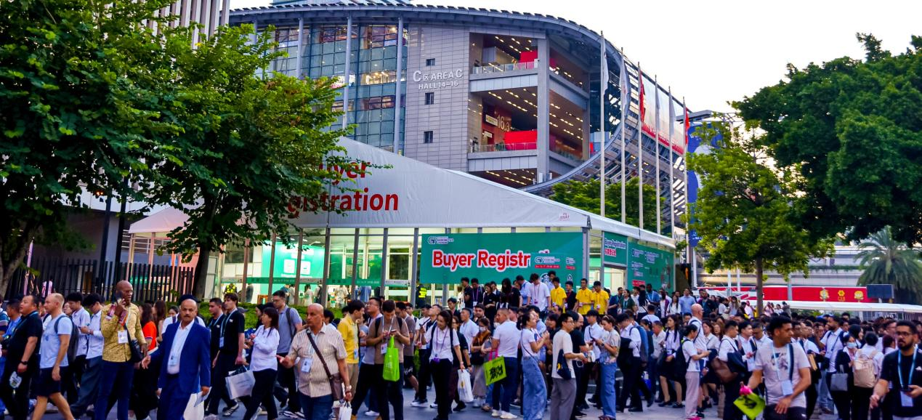
Highlight – What You Will Gain
- Meet 850+ verified, high-quality manufacturers – many sourced from China’s leading government-backed industrial belts.
- Explore 100,000+ new products across hardware & tools, machinery & equipment, motorcycles & accessories, and home appliances – stay ahead into 2027.
- Co-located with the Canton Fair (one day before Phase 1, just a 3-minute walk away) – double your sourcing reach in one trip.
- Enjoy free business matching – share your needs, get pre-matched with exhibitors, and meet them one-on-one to save time.
- Receive exclusive buyer benefits – from dining to entertainment – that make your trip productive and enjoyable.

Product Categories – What You Will Find
- Hardware & Tools: Hand tools, power tools, pneumatic tools, abrasive tools, home hardware, building hardware, and more.
- Machinery & Equipment: Carpentry equipment, spraying machines, hydraulic equipment, cleaning equipment, irrigation systems, garden machinery, lifting & slinging equipment, bearings, pumps, valves, generators, air compressors, motors, welding equipment, etc.
- Motorcycles & Accessories: Motorcycles, parts & accessories, motorcycle supplies; New Energy Vehicles (NEVs), NEV core components; repair & maintenance.
- Home Appliances: Kitchen appliances, domestic appliances, bathroom appliances, health & beauty products, air & water solutions, barbecue utensils, and other accessories.

Exclusive Buyer Benefits – Just Come to Enjoy
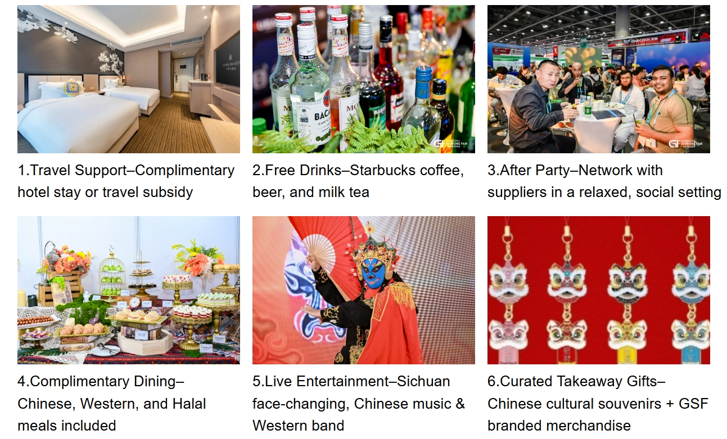

Register Now!
Exhibition Venue: Poly World Trade Center Expo, No. 1000, Xingang East Road, Haizhu District, Guangzhou, China (Opposite Area B, Next to Area C of Canton Fair)
